**Vishwakarma Institute of Technology**

Name- Yash Wagh

Class- AIDS C_B3

Roll – 74

PRN -12111124

Aim- **Execution of basic Linux commands**

1. date

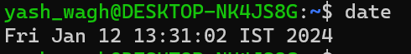

1. cal

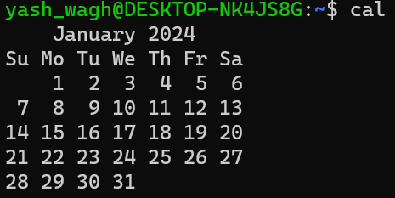

1. whoami



1. echo

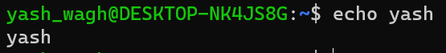

1. bc

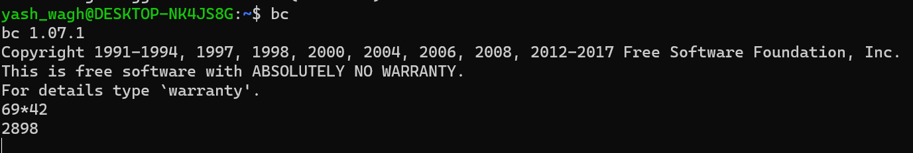

1. alias

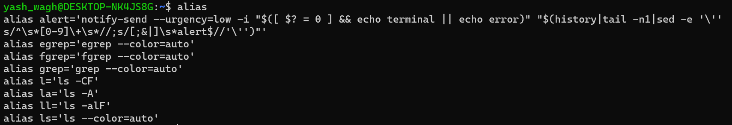

1. man

I used “man who”

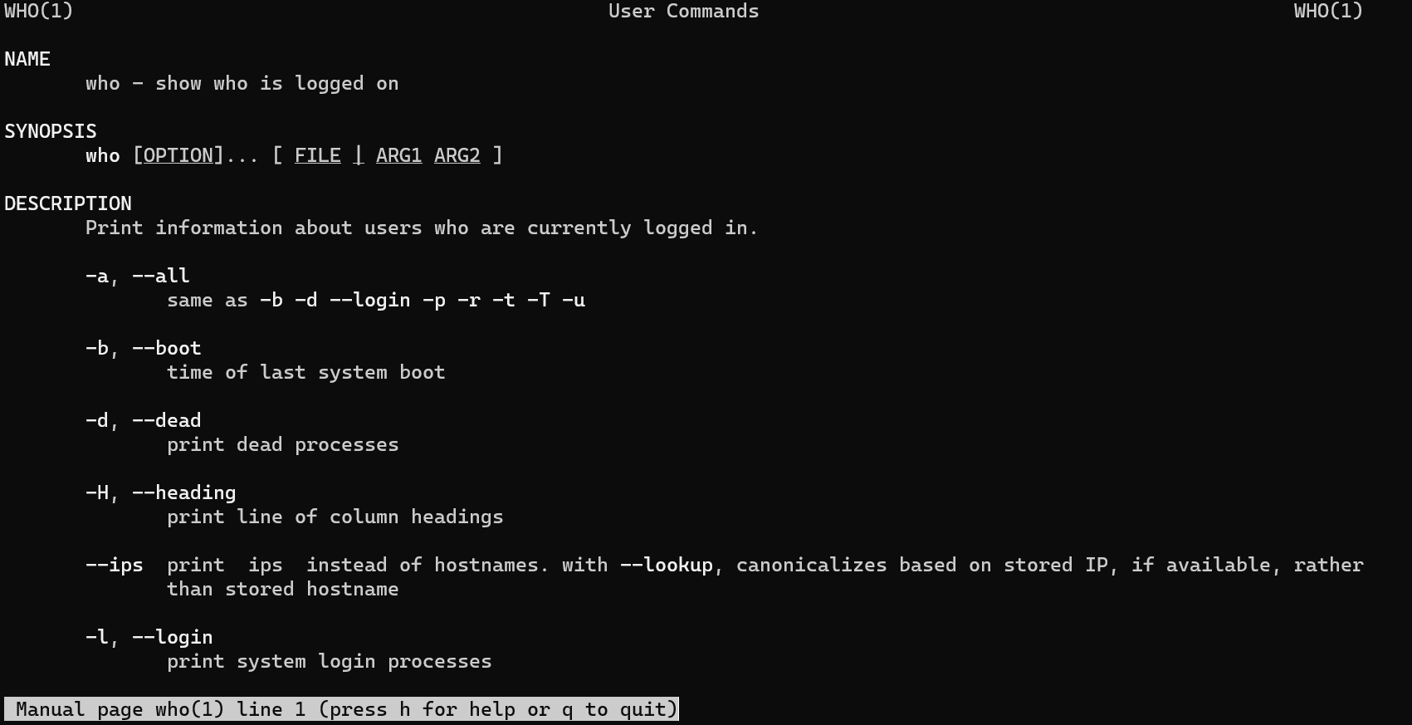

1. cp

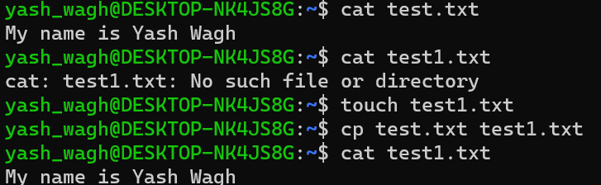

Copy from test.txt to test1.txt successful

1. mv

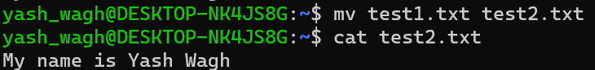

Rename from test1.txt to test2.txt successful

1. rm

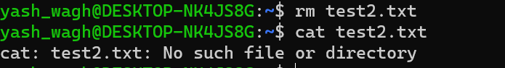

Removal of test2.txt is success

1. mkdir, pwd and cd

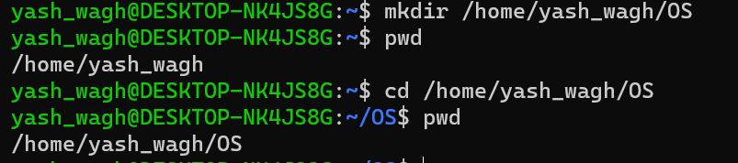

1. rmdir

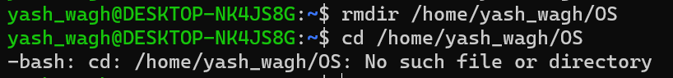

Removal of /home/yash_wagh/OS directory successful.

1. cat>, cat>>, cat

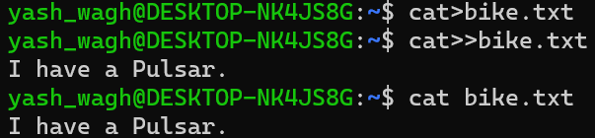

1. more



1. file

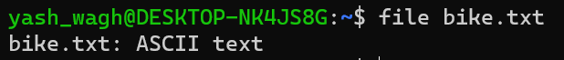

1. wc

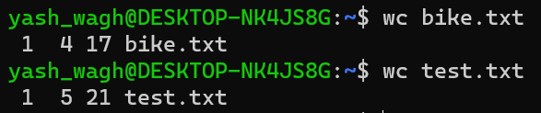

1. cmp



1. comm

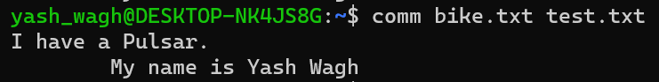

1. diff

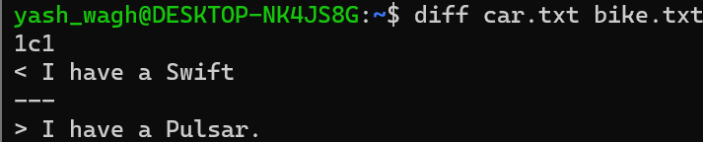

1. gzip and gunzip

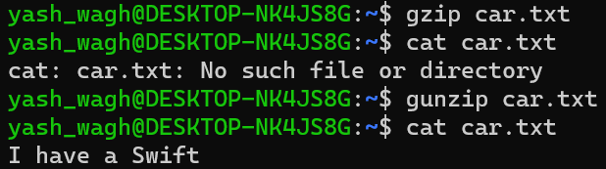

1. ls



1. ls <dir>



1. ln

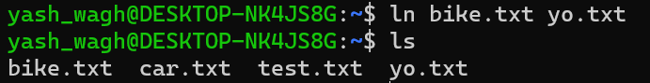

**SUB COMMANDS**

1. ls subcommands

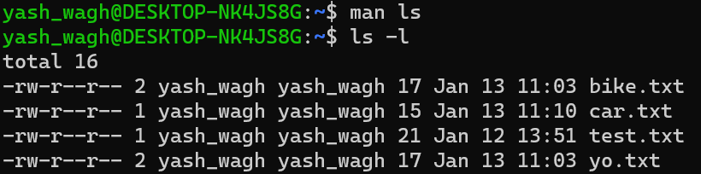

-l gives authors of file



List all files even starting with “.”

1. wc subcommands



Print the byte counts.



Print the character counts.

1. cat subcommands



Print “$” at end of the line.



Number of non empty output lines



1. man subcommands

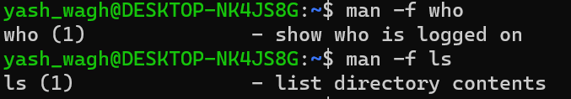

Show the application of commands

1. cp subcommands

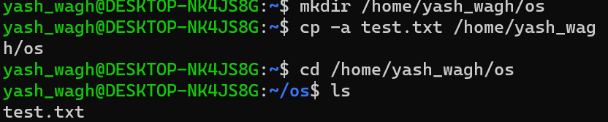

-a preservers all information

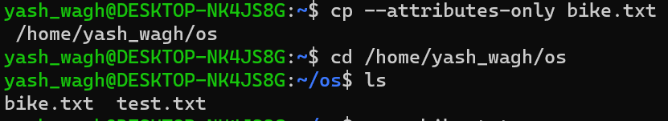

Don’t copy the file data just the attributes.

1. mkdir subcommands

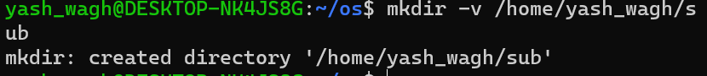

Prints the message

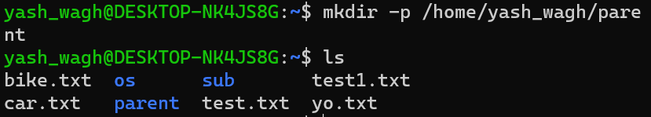

Makes a parent directory.